[CEN 323 ] Computer Organization & Assembly Language

Lab 1 Journal

Enrollment Number: 01-135232-020

Name : 010-135232-020

Lab Deliverables (submission guideline)

  - Create a folder named YourRollNumber_Lab1 containing:
- Lab Journal MS Word file (downloaded from the assignments section on LMS)
- .asm files of the practice tasks and the unseen task.
- Add full screen screenshots of the code and output in the Lab Journal.
  - Zip the Folder and upload to LMS.

Lab Task

Task 1:
Code (TEXT):
.model small

.data
msg db "Fatima Asad", 010,013, "01-135232-020", 010,013, "BS-IT", "$"

.code
main:
mov ax, @data
mov ds,ax
mov dx, offset msg

mov ah,9
int 21h

mov ah,4ch
int 21h
end main
Screenshot (CODE):
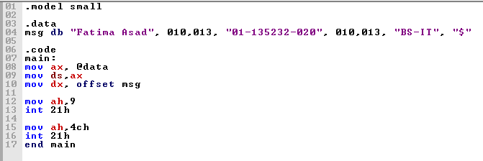
Screenshot (OUTPUT):
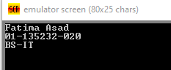

Task 2:
Code (TEXT):
.model small

.data
msg db "This", 0AH, "is", 0AH, "my", 0AH, ""name"", "$"

.code
main:
mov ax, @data
mov ds,ax
mov dx, offset msg

mov ah,9
int 21h

mov ah,4ch
int 21h
end main

Screenshot (CODE):
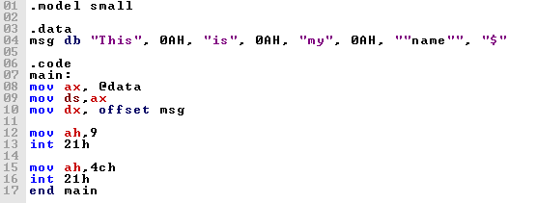

Screenshot (OUTPUT):
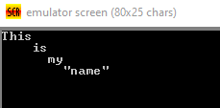
Task 3:
Code (TEXT):
.model small

.data
msg db "*", 010,013, "**", 010,013, "***", 010,013, "****", 010,013, "*****", "$"

.code
main:
mov ax, @data
mov ds,ax
mov dx, offset msg

mov ah,9
int 21h

mov ah,4ch
int 21h
end main

Screenshot (CODE):
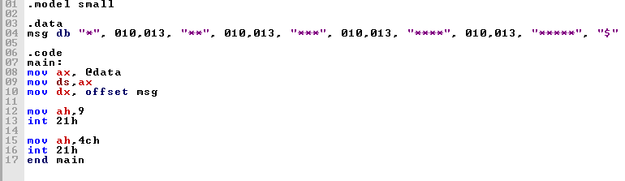

Screenshot (OUTPUT):
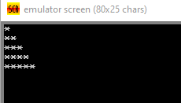

Unseen Task:
Code (text):
.model small

.data
msg db " ****************", 010,013,
db " * * * * * *", 010,013,
db " * **************", 010,013,
db "* * * * * *", 010,013,
db "*******************", 010,013,
db "* * * * * *", 010,013,
db "* * * * * *", 010,013,
db "* ** * ***** *", 010,013,
db "* ** * *", 010,013,
db "*******************", 010,013,
db " * * ", 010,013,
db " ***** ", 010,013, "$"

.code
main:
mov ax, @data
mov ds,ax
mov dx, offset msg

mov ah,9
int 21h

mov ah,4ch
int 21h
end main
Screenshot (TEXT):
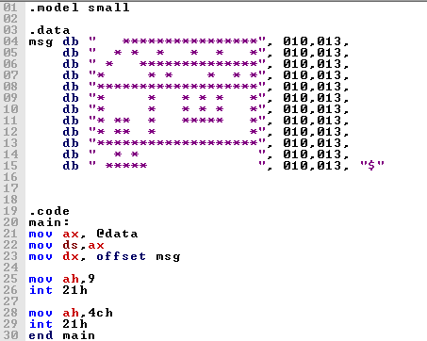

Screenshot (OUTPUT):
